
Birding Trip Report

North-West of Argentina
October 13th to 29th, 2006

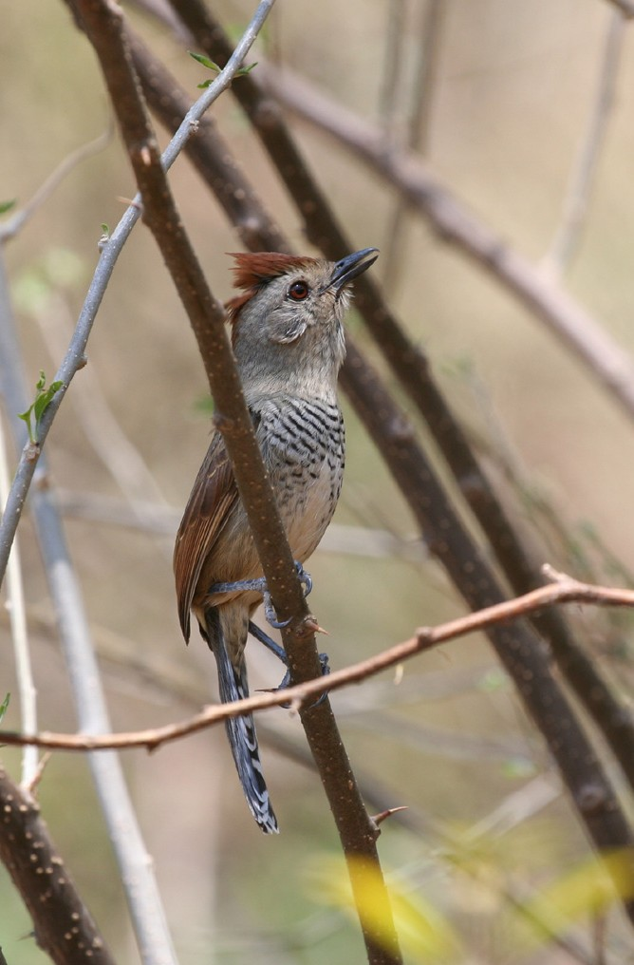

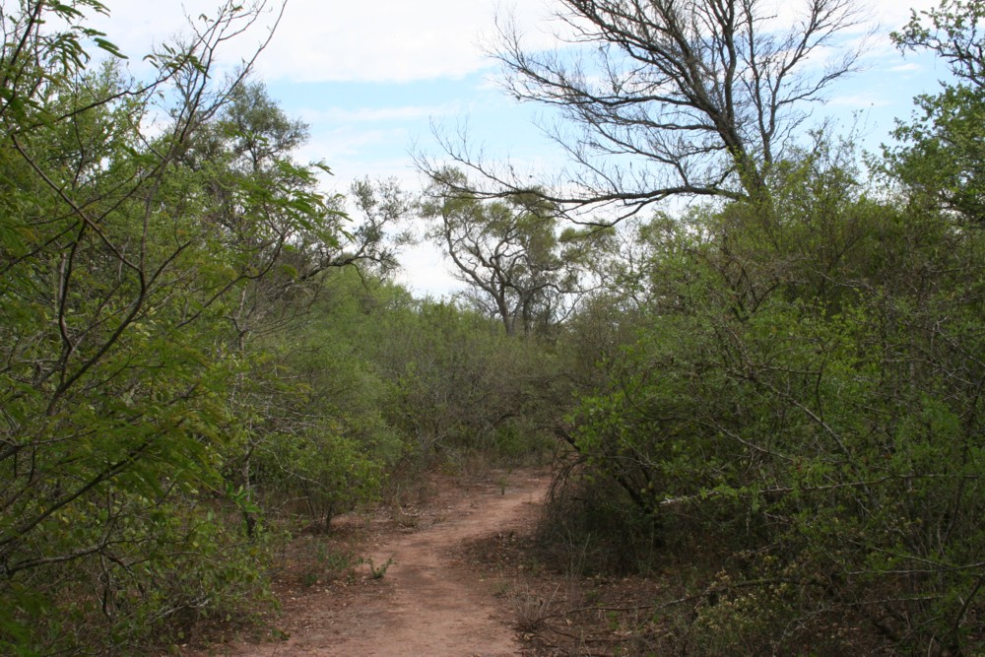

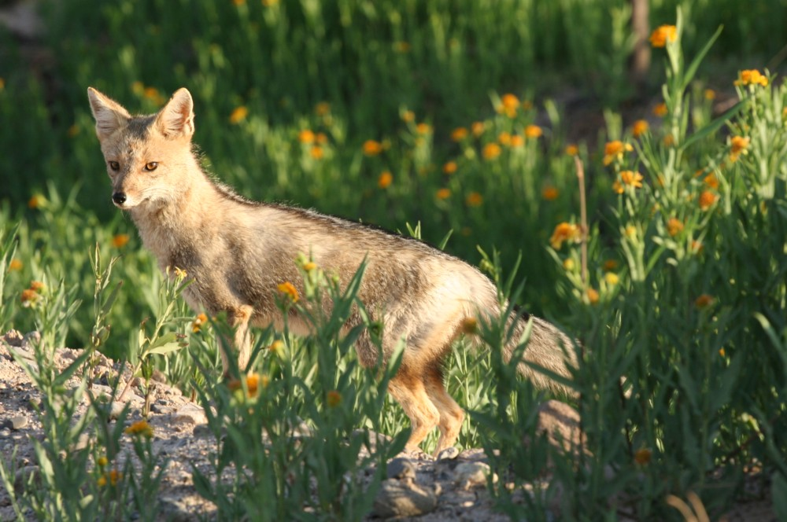

Leader, trip redaction : Fabrice Schmitt
Participants : Skyp and Lyn Nelson
Driver : Julio Benites
Kolibri Expeditions www.kolibriexpeditions.com

While guiding a Kolibri Expeditions 'Central Peru Trip' I had one of most incredible experiences of my life getting to guide for the world famous Skip Nelson and his beautiful wife Lyn in October of 2005.

Skip and Lyn decided to come back to South America in 2006/07for a 6 month trip which included Ecuador, Peru, Bolivia, Argentina and Chile. As I'm living in Chile and am well acquainted with the birds of Argentina and Chile, they kindly asked me if I would like to guide them for the Chile-Argentina part of their trip... of course, I immediately accepted !!

Let's go for a 70 day trip via the northern Chilean desert, Argentinean altiplano, pampas, tropical forest, sea shores, Patagonian scrubs, glaciers, Chilean fjords, etc...
Seventy days full of birds, birds, and birds, but also incredible mammals and landscapes !
Seventy days of great wine, wonderful barbecue, seafood, even lemon liquor with Hoy's Screech-owl singing in the garden of the hotel, ... and of course, peanut butter !! (I guess Skip could not survive 2 weeks without peanut butter, and after this trip, I'm almost addicted…)
Seventy days during which Skip and Lyn where obliged to enjoy my French accent...

This trip report only represents one part of the whole trip : "North-West of Argentina, October 13th to 29th"

Many of the Chilean species were also seen during the North-west Argentina and Patagonian portion of the complete trip.
If you want to have a complete look at our 70 day trip, please read :

- "Few days in the North-east of Argentina, October 31st to November 6th"
- "Patagonia, November 9th to 30th"
- "Central and Northern Chile, with Juan Fernandez island, October 8th to 12th and December 4th to 17th"

If you are interested in a trip in Chile, Argentina or Peru, contact kolibriexp@gmail.com

Itinerary

October 13th
Long day driving between San Pedro de Atacama (Chile) and Jujuy (Argentina).
During this drive, we made some selected stops, to see the 3 Andean species of Flamingos, the Andean Avocet, Brown-backed Mockingbird and our first Spectacled Tyrant.
We even saw an Andean Swallow in Susques (rare bird in Argentina) with a few Barn Swallows.

October 14th
Almost all the day birding in the Yala river where we had crippling views of THE bird of this part of the trip... the Rufous-throated Dipper !!
Other nice species here include Red-tailed Comet, Spot-breasted Thornbird, Stripe-crowned Spinetail, Rufous-capped Antshrike and Slaty Elaenia.
In the afternoon, we drove to Libertador General San Martin, doing a one hour stop in the dry chaco to find some specialists of this habitat. We had good view of Turquoise-fronted Parrot and of some common passerines : Pearly-vented Tody-tyrant, Black-capped Warbling-finch, Red-crested Finch, etc...

October 15th
All the day birding in the impressive Calilegua NP.
We first spent the morning birding the dry forest in the low part of the park, where we had a wonderful view of a pair of Giant Antshrike !
Others highlights here were excellent views of 4 Golden-collared Macaw, 2 Dot-fronted Woodpecker, 1 Great Rufous Woodcreeper, lots of Ochre-faced Tody-flycatcher, Mottle-cheeked Tyrannulet, and many more...
Then we drove higher and higher, doing some stops to add the species at all the elevations, and ending our day at the highest part of the park.
During the day, we had wonderful views of a Toco Toucan and one Cream-backed Woodpecker, and we found some yungas specialists such as White-throated Antpitta, Buff-banded Tyrannulet, Fulvous-headed Brush-finch.
At dusk, we had a close view of Hoy's Screech-owl (we heard 2 more birds) and in the same tree, we had a singing Yungas Pygmy-owl !

October 16th
Early morning in the Calilegua NP, with a stunning view of a Spectacled Owl, and a very quick look on one of 3 singing Rufous Nightjars.
We then drove back to the Yala valley in search of the Red-faced Guan, without success...

October 17th
Early morning for the guan. Even though we heard several of them, impossible to have a look at one... the guan malediction is on us !!
After a very nice breakfast in a very nice place, we had a very long drive to the Pozuelos lagoon where we saw 20 Puna Rheas.
On the way, we also found 2 Aplomado Falcon, some flocks of Golden-spotted Ground-dove, 2 Rufous-banded Miner.

October 18th
We spent the first hour of the morning around Yavi and Yavi Chico to spot 2 Streak-fronted Thornbirds and a few Citron-headed Yellow-finches, and before the Lizoite pass, we had good views of several flocks of Mountain Parakeets, several Plain-throated Earthcreepers, and the most wanted by Skip and Lyn... a flock of about 15 Puna Yellow-finches !
Then we drove back to the Yala valley where the guan malediction still worked : we did wait for them at a roost, and when 3 birds arrived (identified by their voice) the rain did the same and we only saw black silhouettes... impossible to see any red on their face !
We slept in a small hotel in the mountain, where we found Hoy's Screech-owl singing in the garden !!

October 19th
Early morning at the guan roosting place, but today we add fog to the rain... again, we saw the birds but without colors.
Let's leave this humid place and go to the dry chaco !
We drove to Joaquin V Gonzalez with a stop near Palomitas where lot's of forest have been destroyed since the last visit...
We had some good chaco birds today : Tucuman Pygmy-owl, Chaco Earthcreeper, Lark-like Brushrunner, Brown Cachalote, Chaco Suiriri, and also 2 Common Potoo flying over our heads.

October 20th
We completed our chaco list with more species this morning : 8 blue-crowned Parakeet , Crested Hornero, Scimitar-billed Woodcreeper, Plain Tyrannulet and Southern Scrub-Flycatcher, Many-colored Chaco-finch, and a stunning view of 2 Crested Gallito during our breakfast !!
After a couple of resting hours, we drove to the Copo NP for one of our main targets : the Quebracho Crested-Tinamou. The Birdings smiled on us this day and we found 3 of them before reaching the park !
By night, when the Tropical Screech-owls were singing everywhere, we had perfect view of Scissor-tailed Nightjar, and a so close Little Nightjar that Fabrice was able to catch it !

October 21st
A looooooong driving day to Salta, stopped once by a Spotted Nothura, and few other birds...

October 22th
Early breakfast with a male Slender-tailed Woodstar and a calling Red-legged Seriema, on the way to Cafayate.
We drove by a gorgeous landscape today; especially the wonderful arid valley around Cachi.
In the Cuesto del Obispo, we spotted 2 Tucuman Mountain-finch, a very restricted range species close to the Cochabamba Mountain-finch from Bolivia, and 1 Buff-breasted Earthcreeper, endemic from Argentina. On the way, we also had a close view of a Sandy Gallito, and hundreds of Burrowing Parrots. As this beautiful day came to an end we enjoyed the pleaseant climate with a delicious barbecue and a stunning Argentinean wine.
(As a Frenchman, I must admit that the Argentinean wines are far superior to French wines)

October 23th
Early morning not very successful, as we dipped on the Steinbach Canastero...
But on our way to Taffi del Valley, we had a good look at a White-browed Tapaculo, and 2 Yellow-striped Brush-finch, two more Argentinean endemics !

October 24th
Another long driving day, to Cordoba.
We have very few time for birding today, but enough to see two very nice species, first the Dinelli's Doradito, and then a Salinas Monjita on the big salar flats before Cordoba.

October 25th
We spent all the morning and few more hours to look for the Cinnamon Warbling-finch... but a very strong wind gave us a very hard birding day, and it was impossible to find it !
Latter in the day, we had a short stop in the pampas de Achala, where we saw the Olrog's and Comechingones Cinclodes, the Puna Canastero and few Heyllmar's Pipit.

October 26th
Almost all the day birding in the Chancani NP where we did camp. A very good place for chaco species, and with wonderful view of 2 Black-legged Seriemas almost walking between the tents !!
Other good birds here included Scimitar-billed Woodcreeper, Black-crested Finch, Black-bodied Woodpecker, and 6 Scissor-tailed Nightjars.

October 27th
Driving day to Mendoza.
During the way, we stopped in good chaco... and we found 4 Cinnamon Warbling-finch ! Another Argentinean endemic on our list !!
We also had a stunning view of an immature Crowned Eagle which landed on a power pole on the road border just before reaching the Mendoza department.

October 28th
Resting day ! It's so good to sleep a little bit, and taste the Mendoza wine !!

October 29th
The bad day of the north west Argentinean trip...
Lot's of circulation on the way to Chile... so much that we didn't reach the Aconcagua NP and these birds (but of course we will see them during our Chilean part of the trip !).
After a hard search for the Steinbach's Canastero, we dipped on that one... finally, the only target missed on this trip.
Near Potrerillos, a few Sharp-billed Canasteros gave a tick to Skip and Lyn, who have this optimistic slogan "a day with a lifer, is a good day !! "

Some pictures

All pictures from Fabrice Schmitt, and done during this trip.

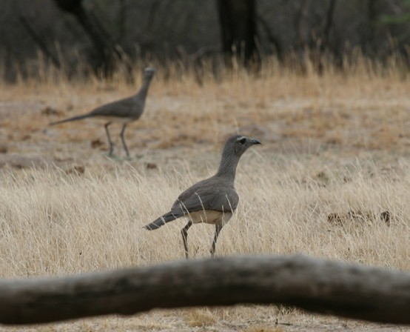
Black-legged Seriema
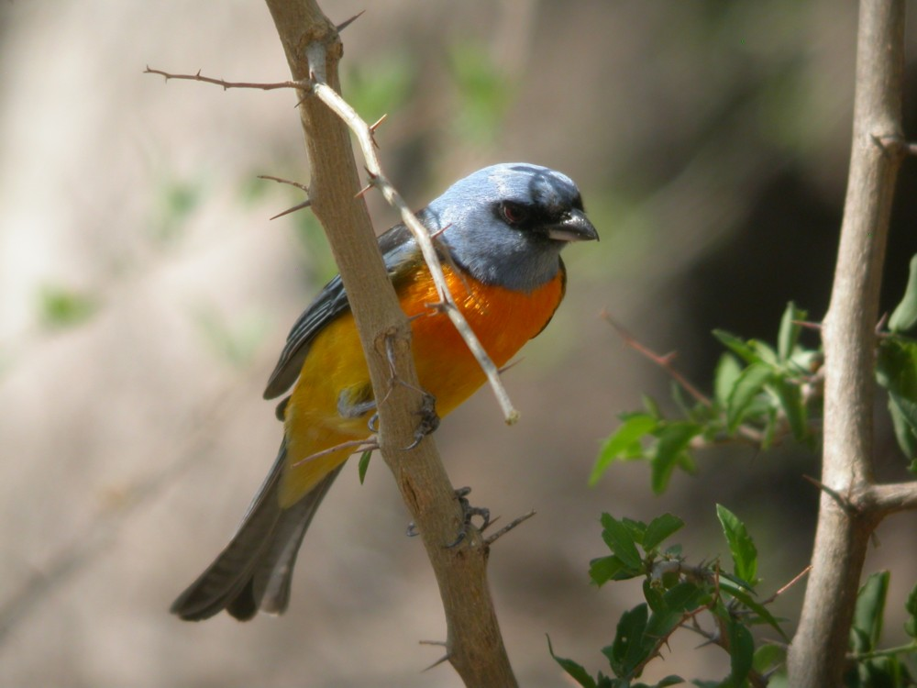
Blue-and-yellow Tanager

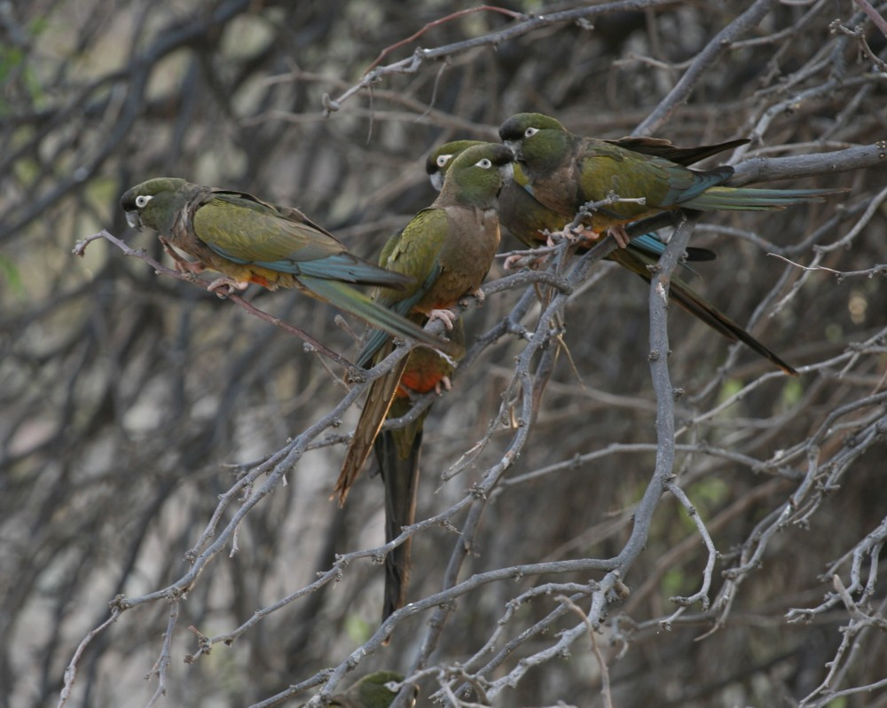
Burrowing Parakeet
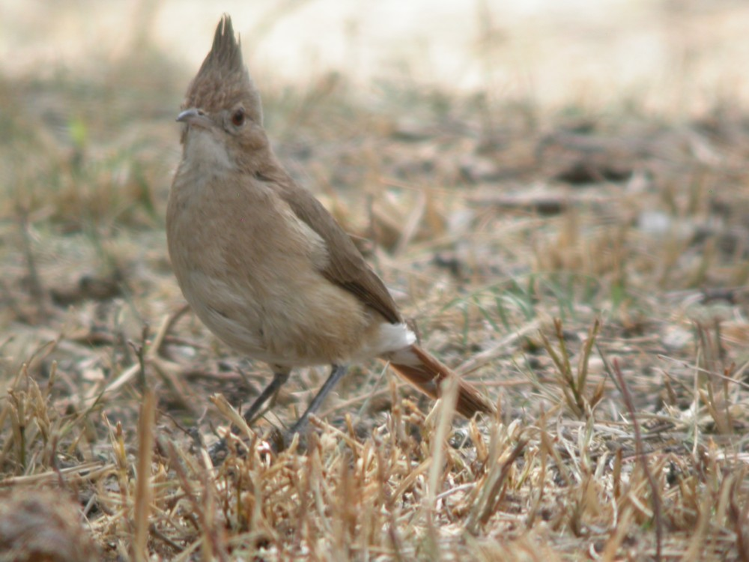
Crested Hornero
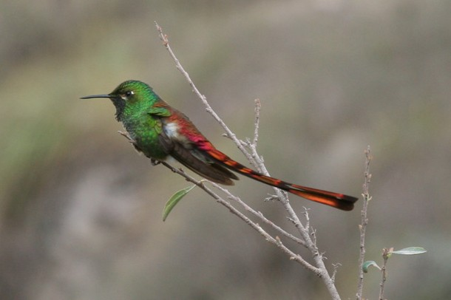
Red-tailed Comet
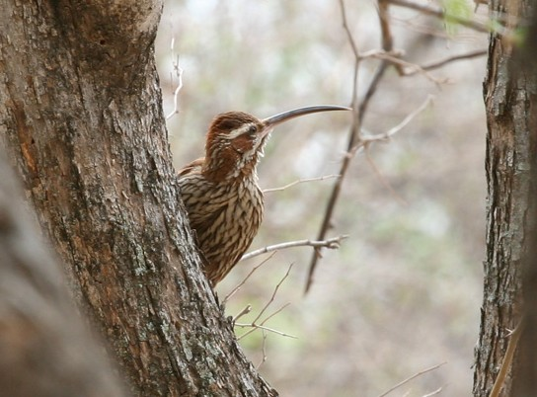
Scimitar-billed Woodcreeper

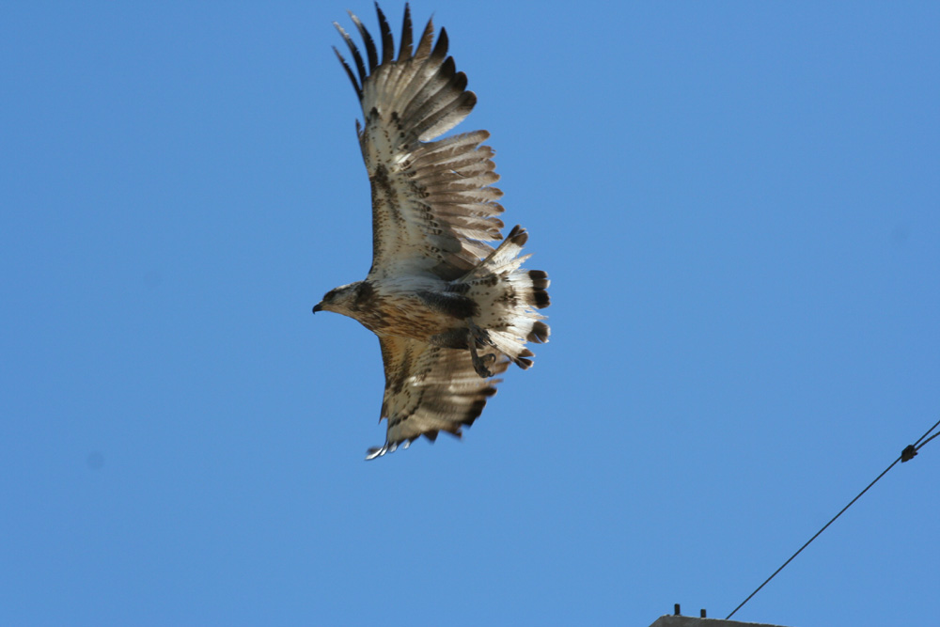
Crowned Eagle
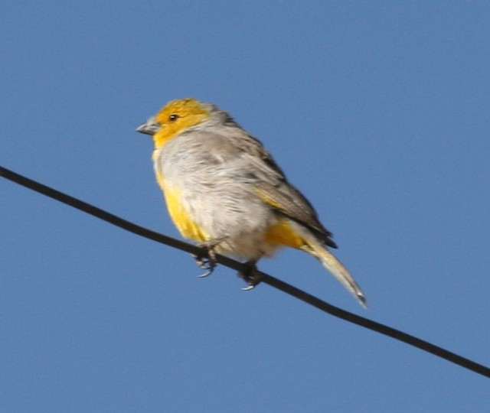
Citron-headed Yellow-finch

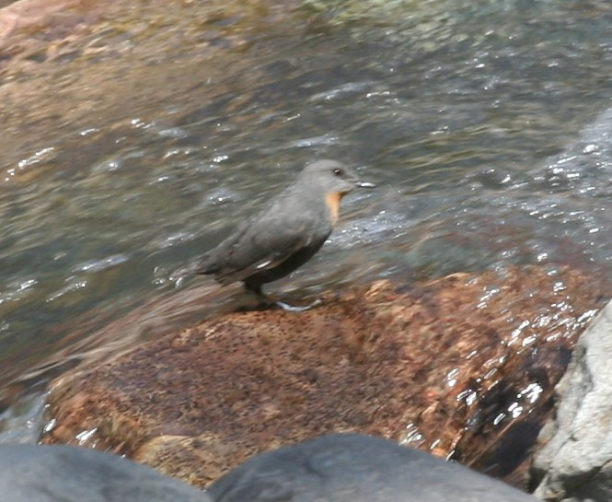
Rufous-throated Dipper
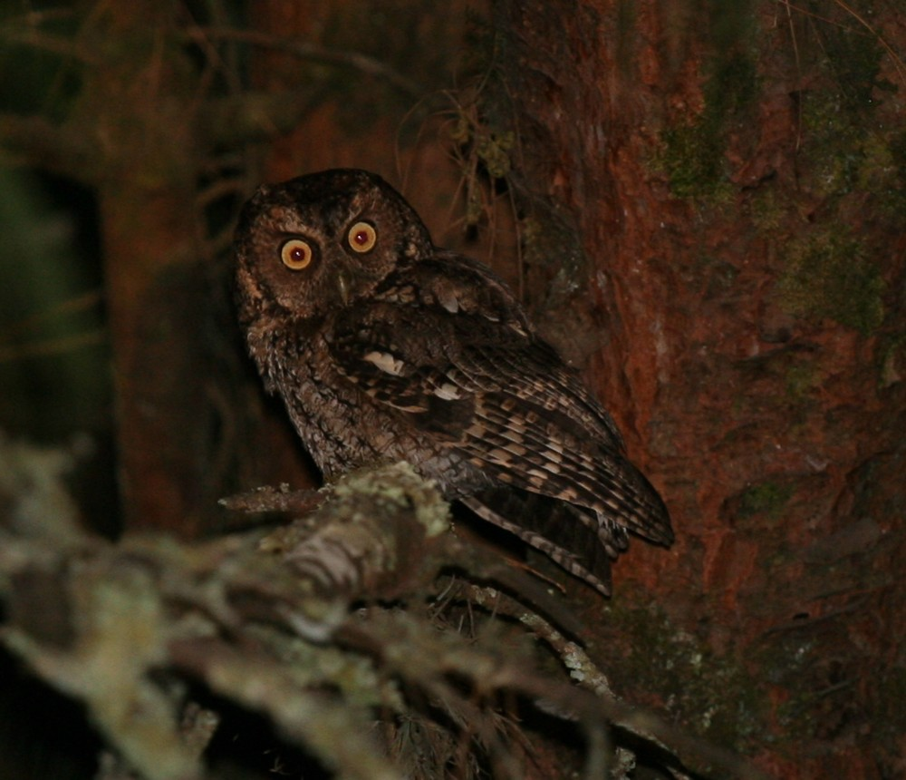
Hoy's Screech-owl
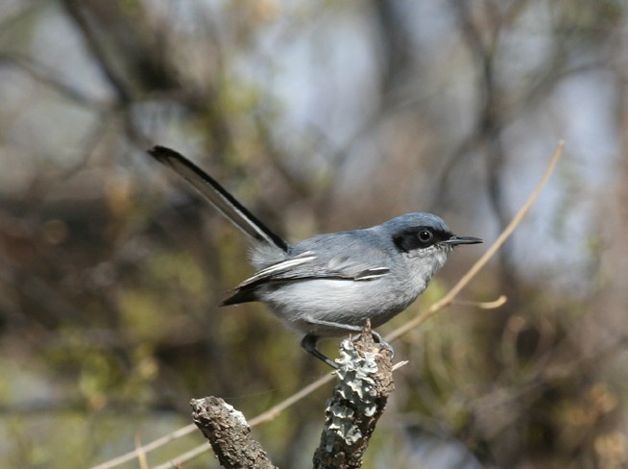
Masked Gnatcatcher
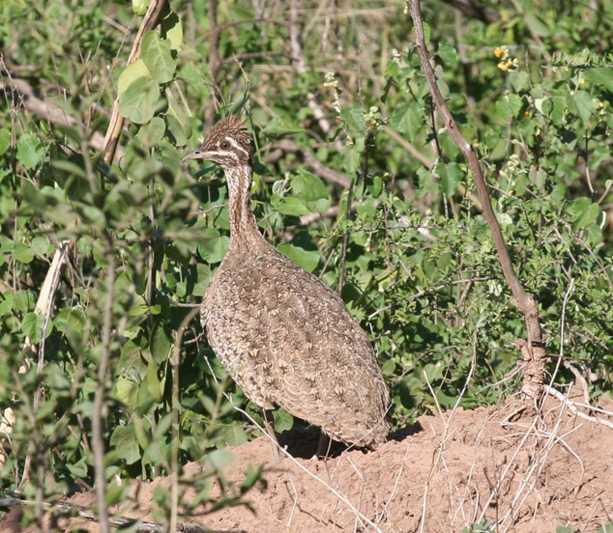
Quebracho Crested Tinamou
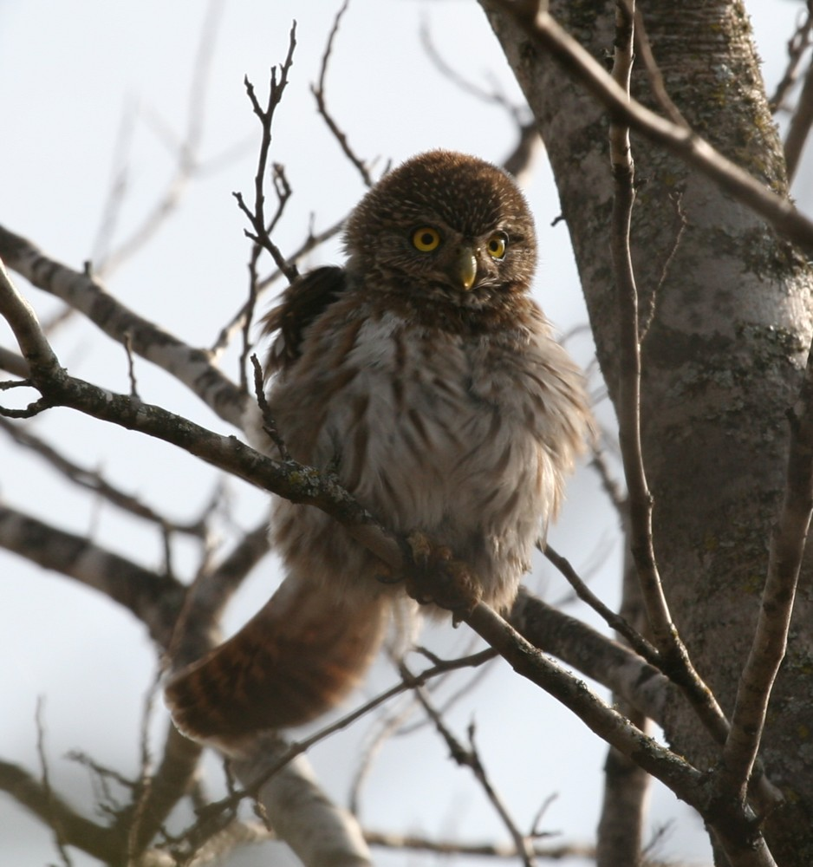
Tucuman Pygmy-owl
Bird List

The * indicates a species whose total range is less than 50.000 km²
The species in bold are globally endangered species. The abbreviation in front of the species name indicate the threat level (nt: near-threatened, Vul: Vulnerable, End: Endangered, Crit: Critical)

nt - Greater Rhea - Rhea americana
1 adult with 10 small chicks on the way to Joaquin V Gonzalez.

nt - Lesser Rhea - Pterocnemia pennata
20 near the Pozuelos lagoon in the altiplano; these ones are of the subspecies garleppi considered by some authors as a full species, the Puna Rhea (Pterocnemia tarapacensis).

Tataupa Tinamou - Crypturellus tataupa
1 seen and several heard in Calilegua NP, heard regularly in the dry chaco

Ornate Tinamou - Nothoprocta ornata
1 crossed the road when we where driving in the direction of the Pozuelos lagoon. Unfortunately, he disappeared in the dry brushlands, and we never had a good look on this bird.

Brushland Tinamou - Nothoprocta cinerascens
At least 3 heard and 1 flushed at Palominas, 1 very good view on a bird walking along the road in Joaquin V Gonzalez, few more seen and heard an the way to Cordoba and in Chancani NP.

Andean Tinamou - Nothoprocta pentlandii
2 flushed in the high part of the Yala valley... but only seen by Fabrice, and the next day, one bird crossed a road near Skyp and Lyn.
1 bird seen very well at about 10 meters from us as if was feeding in a scrub, above Taffi del Vallee

Darwin's Nothura - Nothura darwinii
Heard only in the mountains near Cordoba.

Spotted Nothura - Nothura maculosa
1 spotted by Julio on the side of the road... a nice look !

Quebracho Crested Tinamou - Eudromia formosa
3 birds on the way to Copo NP ! They stayed few minutes on the side of the road, just enough to take some pictures and see very well their brown crest... Punks are not dead !!

White-tufted Grebe - Rollandia rolland
5 on a small pool on the way to Cordoba

Great Grebe - Podiceps major
2 on a small pool on the way to Cordoba

Neotropic Cormorant - Phalacrocorax brasilianus
10 in Calilegua NP, few in the upper Yala valley and more sights latter.

Whistling Heron - Syrigma sibilatrix
2 in Calilegua NP, 1 in the Yala valley, and more isolated birds around Cafayate and on the way to Cordoba.

Great Egret - Ardea alba
1 in Calilegua NP and 1 on the way to Mendoza

Snowy Egret - Egretta thula
1 in the Yala valley and few birds seen on the way to Cafayate.

Cattle Egret - Bubulcus ibis
few above Jujuy, and on the way to Cordoba.

Striated Heron - Butorides striata
2 birds on the small pool where we saw the Dinelli's Doradito.

Black-crowned Night-Heron - Nycticorax nycticorax
1 near one of the lagoons in the high part of the Yala valley, 1 ad in Yavi and 1 near Cafayate.

Buff-necked Ibis - Theristicus caudatus
3 seen in flight near Jujuy

Puna Ibis - Plegadis ridgwayi
1 seen near a small river after the Chilean border

Black Vulture - Coragyps atratus
common

Turkey Vulture - Cathartes aura
common

nt - Andean Condor - Vultur gryphus
4 in the high part of the Yala river, 1 at the Lizoite pass and a nice flock of 18 birds near the El Infernillo pass before Taffi del Vallee.

nt - Chilean Flamingo - Phoenicopterus chilensis
20 in a small lagoon just after the Chilean border, 3 near Abra Pampa

Vul - Andean Flamingo - Phoenicoparrus andinus
10 in a small lagoon just after the Chilean border

nt - Puna Flamingo - Phoenicoparrus jamesi
Seen just before to cross the Argentinean border (see the Chile trip report), but not in Argentina.

Andean Goose - Chloephaga melanoptera
2 near a small river after the Chilean border, 4 near the Pozuelos lagoon, more than 20 near Abra Pampa

Torrent Duck - Merganetta armata
1 pair in the Yala river

Speckled Teal - Anas flavirostris
Severals records of the oxyptera subspecies from the altiplano (perhaps a forthcoming split) : 20 of the near the Pozuelos lagoon, 20 near the Pozuelo lagoon, 1 near Yavi, etc...
Below Tafi del Vallee, we saw the flavirostris subspecies

Crested Duck - Anas specularioides
10 birds near Susques, 10 birds near the Pozuelos lagoon.

Yellow-billed Pintail - Anas georgica
3 on the way to Cafayate.

Hook-billed Kite - Chondrohierax uncinatus
2 in the Calilegua NP

Swallow-tailed Kite - Elanoides forficatus
5 in the Calilegua NP

White-tailed Kite - Elanus leucurus
Few birds along the road between Jujuy and the Calilegua NP, and 1 seen on the way to Villa Dolores.

Cinereous Harrier - Circus cinereus
Several in the altiplano of the Pozuelos lagoon, 1 near the El Infernillo pass.

Bicolored Hawk - Accipiter bicolor
2 in the alder forest of Jujuy, and 1 ad. that we unfortunately flushed below Taffi del Vallee as he was eating a Speckled Teal...

Harris's Hawk - Parabuteo unicinctus
1 seen during our drive between the Copo NP and Salta.

Black-chested Buzzard-Eagle - Geranoaetus melanoleucus
1 ad. in the Yali valley and few around Mendoza

End - Crowned Eagle - Harpyhaliaetus coronatus
1 immature on a power pole on the way to Mendoza. An amazing view on that rare raptor, landed at 50 meters from the minibus.

Roadside Hawk - Buteo magnirostris
Regular sightings in several places.

Short-tailed Hawk - Buteo brachyurus
1 dark form in the Yala valley.

Red-backed Hawk - Buteo polyosoma
1 near Libertador General San Martin and few birds in the Cachi-Cafayate area.

Puna Hawk - Buteo poecilochrous
A total of 3 birds in the altiplano in north Jujuy. The Red-backed and Puna Hawk have been lump in the past as Variable Hawk, but are now considered as valid species.

Mountain Caracara - Phalcoboenus megalopterus
Fairly common in the altiplano in the north Jujuy.

Southern Caracara - Caracara plancus
Fairly common in the lowlands

Chimango Caracara - Milvago chimango
More and more common as we are driving south.

Barred Forest-Falcon - Micrastur ruficollis
1 heard only in the yungas of the Calilegua NP.

Spot-winged Falconet - Spiziapteryx circumcinctus
Grrrrrrr.... heard only in the Chancani NP.

American Kestrel - Falco sparverius
Common

Aplomado Falcon - Falco femoralis
1 in the Yala valley, 2 birds seen near the Pozuelos lagoon, and 1 just after the Cuesta del Obispo pass.

Peregrine Falcon - Falco peregrinus
1 in the Calilegua NP

Chaco Chachalaca - Ortalis canicollis
At least 7 birds seen around Palomitas, few birds seen and more heard near Joaquin V Gonzalez, fairly common also in Copo NP.

* Red-faced Guan - Penelope dabbenei
We were particularly unlucky with that one... We first spend one full afternoon loocking for the guan, during with we only heard one. The next morning, we heard at least two birds and they were so close that it was possible to hear the wing flapping...but impossible to see one. We did then wait them at their roosting place, but when they arrived in the late afternoon, the rain did the same and we only saw 3 "silhouettes" in the dark. The next morning, with the rain we also had a incredible fog (impossible to see farther than 100 meters) and the 3 birds weren't more colourful !
Impossible so to see the red face... but the donkey "hi-haan" contact-alarm call we heard several times is characteristic of Red-faced Guan.

Dusky-legged Guan - Penelope obscura
One spectacular view on 1 bird in the Yala valley... even if we were looking and expecting a Red-faced one !!

Limpkin - Aramus guarauna
1 near a small pool on the way to Libertador General San Martin

Plumbeous Rail - Pardirallus sanguinolentus
1 on the shore of a river on the way to Cafayate, and one seen in the Pampa de Achala (with the two endemic Cinclodes !!)

Common Moorhen - Gallinula chloropus
3 on a small pool on the way to Cordoba

White-winged Coot - Fulica leucoptera
Around 10 birds seen on a small lake during our hard search for Cinnamon Warbling-finch, north of San Carlos.

Slate-colored Coot - Fulica ardesiaca
10 birds on a small lake in the upper Yala valley

Red-gartered Coot - Fulica armillata
5 with the White-winged Coots.

Red-legged Seriema - Cariama cristata
1 heard during our breakfast, between Salta and the Cuesta del Obispo.

Black-legged Seriema - Chunga burmeisteri
Several birds heard near Palomitas, and 2 very co-operative birds in the Chancani NP.

White-backed Stilt - Himantopus (mexicanus) melanurus
5 on a small lake in the upper Yala valley

Andean Avocet - Recurvirostra andina
1 bird seen just after the Chilean border

Southern Lapwing - Vanellus chilensis
Common

Andean Lapwing - Vanellus resplendens
Common in the altiplano in the north of the Jujuy department, 2 birds in the upper Yala valley and also 1 near the El Infernillo pass.

Gray-breasted Seedsnipe - Thinocorus orbignyianus
3 in the altiplano in the north of the Jujuy department

Andean Gull - Larus serranus
Few birds seen in the altiplano and along the river near Cafayate.

Rock Pigeon - Columba livia
Common in every cities

Picazuro Pigeon - Patagioenas picazuro
3 in the low part of the Yala valley, common in the dry chaco

Spot-winged Pigeon - Patagioenas maculosa
A small group in Yavi and few more birds in the south, especially in the Chancani NP

Band-tailed Pigeon - Patagioenas fasciata
3 in the high part of the Calilegua NP

Pale-vented Pigeon - Patagioenas cayennensis
Fairly common in the low part of the Calilegua NP

Eared Dove - Zenaida auriculata
Common, very abundant in the chaco around Joaquin V Gonzalez where flocks of hundreds (if not thousands !) of birds are contacted

Picui Ground-Dove - Columbina picui
Fairly common

Bare-faced Ground-Dove - Metriopelia ceciliae
Few seen in Yavi and Yavi Chico

* Bare-eyed Ground-Dove - Metriopelia morenoi
3 seen in the Cuesta del Obispo, and 6 near the El Infernillo pass.

Black-winged Ground-Dove - Metriopelia melanoptera
Few seen in Yavi, and some flocks in the Cuesta del Obispo and El Infernillo.

Golden-spotted Ground-Dove - Metriopelia aymara
Fairly common near the Pozuelos lagoon

White-tipped Dove - Leptotila verreauxi
Common in the dry chaco

White-faced Dove - Leptotila megalura
Common in the Calilegua NP, also heard in the upper Yala valley and in the Yungas on the way to the Cuesta del Obispo.

White-throated Quail-Dove - Geotrygon frenata
At least 3 different birds seen in the upper part of the Calilegua NP

Yellow-collared Macaw - Primolius auricollis
1 seen flying over the dry chaco before Libertador General San Martin, very good view on 4 birds in the lower part of the Calilegua NP

Blue-crowned Parakeet - Aratinga acuticaudata
8 birds near Joaquin V Gonzalez scoped during our breakfast, at least 8 birds in the Copo NP, and more than 10 in the Chancani NP

Mitred Parakeet - Aratinga mitrata
Big flocks in the high part of the Calilegua NP; also seen above Salta.

Burrowing Parakeet - Cyanoliseus patagonus
More than 700 seen on the way to Cafayate. The next morning, some big flocks are seen around Cafayate, and even from the main place of the village.

Green-cheeked Parakeet - Pyrrhura molinae
Good views in the Calilegua NP

Monk Parakeet - Myiopsitta monachus
The first ones are seen near Joaquin V Gonzalez, and then the species became more and more common as we were driving south. In the Chancani NP, they were breeding at 50 meters from our tents.

Gray-hooded Parakeet - Psilopsiagon aymara
Several flocks in the mountain of north Jujuy, very close view on a small flock in Yavi and around 10 birds together in the Cuesta del Obispo.

Mountain Parakeet - Psilopsiagon aurifrons
3 flocks for a total of about 35 birds before the Lizoite pass. We had a very good view at only 15 meters from our minibus, that permit us to see the difference of the bill coloration between male and female

Scaly-headed Parrot - Pionus maximiliani
Few birds but good view in the Calilegua NP

* nt - Tucuman Parrot - Amazona tucumana
2 seen in flight near Jujuy, and 10 with Mitred Parakeet in the Calilegua NP

Blue-fronted Parrot - Amazona aestiva
3 in the dry chaco before Libertador General San Martin, 2 near Joaquin V Gonzalez and 1 in the Copo NP.

Squirrel Cuckoo - Piaya cayana
1 in the Calilegua NP

Guira Cuckoo - Guira guira
Fairly common in the lowlands.

Striped Cuckoo - Tapera naevia
Often heardt in the lowlands, but we had a quick view on one in the Copo NP.

Tropical Screech-Owl - Megascops choliba
1 heard in the lower part of the Calilegua NP, several heard in the Copo NP and also in the Chancani NP (we didn't try to have a look on this common neotropic owl).

Hoy's Screech-Owl - Megascops hoyi
1 very good view on one bird responding to the playback, and 2 more birds heard in the Calilegua NP. 1 more is found singing in a Pine tree close to our hotel in the upper Yala valley, permiting us to have a wonderful sight and take some pictures.

Spectacled Owl - Pulsatrix perspicillata
One wonderful view during the sunrise in the Calilegua NP

Yungas Pygmy-Owl - Glaucidium bolivianum
1 almost in the same tree than the Hoy's Screech-Owl !!

Tucuman Pygmy-Owl - Glaucidium (brasilianum) tucumanum
1 very well seen by daylight near Palomitas, an other one near Joaquin V Gonzalez, 1 in the Chancani NP. The tucumanum subspecies is splitted by many authors.

Burrowing Owl - Athene cunicularia
1 in the altiplano in the north of Jujuy, and 1 on the way to Joaquin V Gonzalez.

Common Potoo - Nyctibius griseus
2 seen and one more heard near Joaquin V Gonzalez, at least 2 singing in the Copo NP.

Rufous Nightjar - Caprimulgus rufus
2-3 birds singing in the Calilegua NP, one of them seen but only flying

Little Nightjar - Caprimulgus parvulus
At least 3 heard near Joaquin V Gonzalez... but impossible to spot them !
Lot's of singers in the Copo NP where we found a bird on a trail... so close, so close, so close.... that I was able to catch it !!!!
Several heard also in Chancani.

Scissor-tailed Nightjar - Hydropsalis torquata
1 in Copo NP, and 6 in Chancani, all seen landed very close to us !

White-collared Swift - Streptoprocne zonaris
A big flock in the chaco near Palomitas.

Sick's Swift - Chaetura meridionalis
Common in the Calilegua NP, also seen in the chaco and 2 in Chancani.

Andean Swift - Aeronautes andecolus
Common in the altiplano in the north of Jujuy department, more than 50 above Salta, and also 2 birds below Uspallata.

Glittering-bellied Emerald - Chlorostilbon aureoventris
Fairly common (Yala valley, Calilegua NP, dry chaco)

Gilded Sapphire - Hylocharis chrysura
2 in the dry chaco at Palomitas

White-bellied Hummingbird - Leucippus chionogaster
Common in the Yala valley and in the Calilegua NP, 3 also seen above Salta.

* Blue-capped Puffleg - Eriocnemis glaucopoides
3 in the Calilegua NP

Red-tailed Comet - Sappho sparganura
Fairly common in the Yala valley, also seen near Salta, around Cordoba and above Mendoza.

Blue-tufted Starthroat - Heliomaster furcifer
1 female in the Copo NP, and 1 north of Juan Carlos.

Slender-tailed Woodstar - Microstilbon burmeisteri
Whaouuu !!! Competing with the Red-tailed Comet for the most beautiful hummer of the trip !
A splendid male during our breakfast above Salta.

Blue-crowned Trogon - Trogon curucui
1 pair very well seen in the Calilegua NP

Ringed Kingfisher - Megaceryle torquata
1 in the upper Yala valley

Green Kingfisher - Chloroceryle americana
1 landed on a small bridge, north of Juan Carlos.

Chaco Puffbird - Nystalus (maculatus) striatipectus
1 heard only in the dry chaco at Palomitas, and 1 scoped near Joaquin V Gonzalez.
The subspecies striatipectus of the Spot-backed Puffbird (N. maculatus) is often considered as a valid species.

Toco Toucan - Ramphastos toco
One wonderful view of 1 bird in the Yala valley, and other good sighting in the Calilegua NP., 1 also seen during our drive to Joaquin V Gonzalez.

Ocellated Piculet - Picumnus dorbygnianus
A total of 6 birds in the Calilegua NP

White Woodpecker - Melanerpes candidus
3 in the Copo NP.

White-fronted Woodpecker - Melanerpes cactorum
Fairly common in Chancani.

Checkered Woodpecker - Picoides mixtus
2 in the dry chaco at Palomitas and few more near Joaquin V Gonzalez and in the Copo NP.

Dot-fronted Woodpecker - Veniliornis frontalis
2 in the Calilegua NP and 1 on the way to the Cuesta del Obispo.

Golden-olive Woodpecker - Piculus rubiginosus
2 in the Calilegua NP

Green-barred Woodpecker - Colaptes melanochloros
2 near Joaquin V Gonzalez and 1 north of Juan Carlos.

Andean Flicker - Colaptes rupicola
1 in the village of Yavi, and 3 near the pass above the Cuesta del Obispo.

Campo Flicker - Colaptes campestris
Few birds seen in the Copo NP.

nt - Black-bodied Woodpecker - Dryocopus schulzi
2 birds seen at 30 meters from our tent in the Chancani NP !!

Cream-backed Woodpecker - Campephilus leucopogon
One spectacular view on 1 bird in the Calilegua NP

Common Miner - Geositta cunicularia
1 well seen in a total of about 10 birds near the Pozuelo lagoon; these birds belong to the titicacae subspecies.

Puna Miner - Geositta punensis
Common in the altiplano of north Jujuy

Rufous-banded Miner - Geositta rufipennis
1 seen on a rocky place on the way to the Pozuelos lagoon, 2 in the Cuesta del Obispo, and 2 below Uspallata.

Plain-breasted Earthcreeper - Upucerthia jelskii
At least 3 birds seen before the Lizoite pass

Buff-breasted Earthcreeper - Upucerthia validirostris
2 in a small gully near the pass of the Cuesta del Obispo.

Straight-billed Earthcreeper - Upucerthia ruficauda
Few seen below Susques, and 1 between Huamahuaca and Abra Pampa.

Rock Earthcreeper - Upucerthia andaecola
2 seen very well in the Cuesta del Obispo.

Chaco Earthcreeper - Ochetorhynchus certhioides
2 heard and 1 very well seen in the dry chaco in Palomitas, several seen and heard in Chancani.

* Olrog's Cinclodes - Cinclodes olrogi
2 in the Pampa del Achala.

Bar-winged Cinclodes - Cinclodes fuscus
Few seen in the highlands.

* Cordoba Cinclodes - Cinclodes comechingonus
4 in the Pampa del Achala.

White-winged Cinclodes - Cinclodes atacamensis
2 along the small river in Yavi

Rufous Hornero - Furnarius rufus
Common in the lowlands

Crested Hornero - Furnarius cristatus
2 pairs seen near Joaquin V Gonzalez, more heard... and 2 walking between our tents in the Chancani NP.

Plain-mantled Tit-Spinetail - Leptasthenura aegithaloides
3 of the berlepshi subspecies seen around Yavi.

Tufted Tit-Spinetail - Leptasthenura platensis
1 north of Juan Carlos and 1 in the Chancani NP.

Brown-capped Tit-Spinetail - Leptasthenura fuliginiceps
2 in the Cuesta del Obispo, and 2 near the El Infernillo pass.

Wren-like Rushbird - Phleocryptes melanops
Heard in a small marsh on the way to Cordoba.

Ochre-cheeked Spinetail - Synallaxis scutata
Very common in the low part of the Calilegua NP

Azara's Spinetail - Synallaxis azarae
Only one seen but several heard in the high part of the Calilegua NP

Sooty-fronted Spinetail - Synallaxis frontalis
1 heard in the low part of the Calilegua NP and common in the dry chaco. Several heard also in Chancani.

Stripe-crowned Spinetail - Cranioleuca pyrrhophia
Fairly common in all the Yala valley, also several birds seen in the Calilegua NP and the dry chaco.

Rusty-vented Canastero - Asthenes dorbignyi dorbignyi
Easy to find between Huamahuaca and Abra Pampa

Sharp-billed Canastero - Asthenes pyrrholeuca
3 birds seen around Potrerillos

Short-billed Canastero - Asthenes baeri
1 well seen in the Copo NP, more in Chancani, and 2 above Mendoza.

Cordilleran Canastero - Asthenes modesta
Common in the altiplano in north Jujuy

Puna Canastero - Asthenes sclateri
1 in the Pampa del Achala.

Rufous-fronted Thornbird - Phacellodomus rufifrons
Common in the lowlands between Jujuy and Libertador General San Martin.

Little Thornbird - Phacellodomus sibilatrix
3 seen after playback in the Copo NP.

Streak-fronted Thornbird - Phacellodomus striaticeps
Easy to find between Huamahuaca and Abra Pampa, and around Yavi.

Spot-breasted Thornbird - Phacellodomus maculipectus
Fairly common in the Yala valley

Lark-like Brushrunner - Coryphistera alaudina
2 seen at about 10 meters near Joaquin V Gonzalez, 2 more north of Juan Carlos and 2 in Chancani NP.

Brown Cacholote - Pseudoseisura lophotes
In the tree above the brushruners near Joaquin V Gonzalez !! Often heard in the dry chaco near Joaquin V Gonzalez, and one pair was building a nest near our tent in the Chancani NP.

White-throated Cacholote - Pseudoseisura gutturalis
2 birds near their nest few kilometres before reaching Cafayate.

Streaked Xenops - Xenops rutilans
1 bird singing near a hole in a dead stick (probable nesting cavity), and 2 more seen, all in the Calilegua NP

Buff-browed Foliage-gleaner - Syndactyla rufosuperciliata
Common in the Calilegua NP and in the Yala valley. It's usually one of the first species to alarm after a pygmy-owl playback.

Scimitar-billed Woodcreeper - Drymornis bridgesii
1 pair seen near Joaquin V Gonzalez... what a bill !!
Also seen north of Juan Carlos, and a pair was foraging close to our campsite in the Chancani NP !

Great Rufous Woodcreeper - Xiphocolaptes major
Only 1 seen in Calilegua NP, but what a great look ! 1 more heard near Joaquin V Gonzalez

Narrow-billed Woodcreeper - Lepidocolaptes angustirostris
Common in the low part of the Calilegua NP and in the dry chaco.

Giant Antshrike - Batara cinerea
An amazing view on an amazing bird !! We had a pair at about 10 meters from us... one of the birds of the trip!

Variable Antshrike - Thamnophilus caerulescens
Fairly common in the Calilegua NP

Rufous-capped Antshrike - Thamnophilus ruficapillus
1 singer in the low part of the Yala river. Also heard in the dry chaco

Black-capped Antwren - Herpsilochmus atricapillus
Easier to ear than to see, but we had several views in the low part of the Calilegua NP

* White-throated Antpitta - Grallaria albigula
Few heard in the low part of the Calilegua NP... and several in the higher part. Already on the list of everybody, we didn't try to playback it.

Crested Gallito - Rhinocrypta lanceolata
Commonly heard in the dry chaco near Joaquin V Gonzalez... but not so easy to find. Finally, we had one singing almost in the top of a brush and we scoped him for few minutes during our breakfast !!!

Sandy Gallito - Teledromas fuscus
Too easy... we randomly playbacked on our way to Cachi, and one arrived directly in the open and at only 20 meters from us !!

Olive-crowned Crescent-chest - Melanopareia maximiliani
A very nice view on one bird in the Copo NP.

* White-browed Tapaculo - Scytalopus superciliaris
We first found one near the El Infernillo pass, but only Lyn saw it... Skyp decided then to stop birding and to begin a list of animals less difficult to find, as snails or worms...
Fortunately, we found another tapaculo 2 hours later, just below Taffi del Valle ! Skyp is again in the game !!

White-tipped Plantcutter - Phytotoma rutila
1 seen near Joaquin V Gonzalez, 2 in the Cuesta del Obispo, and several birds in the Chancani NP.

Southern Beardless-Tyrannulet - Camptostoma obsoletum
1 in the dry chaco in Palomitas

Mouse-colored Tyrannulet - Phaeomyias murina
1 in the chaco on the way to Cordoba

White-crested Elaenia - Elaenia albiceps
Few found in the alder forest in the Calilegua NP and in the Yala valley, and latter in Chancani.

Small-billed Elaenia - Elaenia parvirostris
2 very responsive in the low part of the Yala river. Fairly common in the lowlands.

* Slaty Elaenia - Elaenia strepera
1 mostly heard in the Yala valley, severals heard and seen in the high part of the Calilegua NP.

Highland Elaenia - Elaenia obscura
2 well seen in the high part of the Calilegua NP. Also heard in the upper Yala valley.

White-bellied Tyrannulet - Serpophaga munda
1 in the Yala valley, and very common in the dry chaco.

Mottle-cheeked Tyrannulet - Phylloscartes ventralis
Good view on 2 birds in the low part of the Calilegua NP.

Sclater's Tyrannulet - Phyllomyias sclateri
Heard only in the Yala valley. Seems common in the Calilegua NP where we had good views on few birds.

Southern Scrub-Flycatcher - Sublegatus modestus
1 in the dry chaco near Joaquin V Gonzalez

Suiriri Flycatcher - Suiriri suiriri
Heard everytime in the dry chaco, and seen sometimes... mainly when we where playbacking the pygmy-owl !

White-throated Tyrannulet - Mecocerculus leucophrys
In the alder forest (Calilegua NP, Yala, Taffi del Vallee)

Buff-banded Tyrannulet - Mecocerculus hellmayri
With the precedent species, in the alder forest.

Plain Tyrannulet - Inezia inornata
1 in the dry chaco near Joaquin V Gonzalez.

Greater Wagtail-Tyrant - Stigmatura budytoides
Common in the dry chaco.

Yellow-billed Tit-Tyrant - Anairetes flavirostris
One on a random stop before Cafayate.

Tufted Tit-Tyrant - Anairetes parulus.
2 in the Cuesta del Obispo.

nt - Dinelli's Doradito - Pseudocolopteryx dinellianus
1 very well seen on the way to Cordoba.

Tawny-crowned Pygmy-Tyrant - Euscarthmus meloryphus
2 in Copo NP.

Pearly-vented Tody-Tyrant - Hemitriccus margaritaceiventer
Few heard and 1 seen in the low part of the Calilegua NP, also in the dry chaco near Joaquin V Gonzalez and in Chancani.

Ochre-faced Tody-Flycatcher - Todirostrum plumbeiceps
Very common in the Calilegua NP

Yellow-olive Flycatcher - Tolmomyias sulphurescens
1 seen in the Calilegua NP

Bran-colored Flycatcher - Myiophobus fasciatus
A total of 6 birds seen in Chancani NP.

Cinnamon Flycatcher - Pyrrhomyias cinnamomea
Few in the Yala valley and Calilegua NP.

Cliff Flycatcher - Hirundinea ferruginea
A total of 5 on the way to Cafayate.

Smoke-colored Pewee - Contopus fumigatus
In the alder forest (Yala, Calilegua)

Tropical Pewee - Contopus cinereus
2 seen in the Yala valley

Black Phoebe - Sayornis nigricans
A pair was nesting under the bridge on the Yala river.

Vermilion Flycatcher - Pyrocephalus rubinus
Few seen before Cafayate and around Villa Dolores.

D'Orbigny's Chat-Tyrant - Ochthoeca oenanthoides
2 seen around Yavi, and 2 more in the Cuesta del Obispo.

White-browed Chat-Tyrant - Ochthoeca leucophrys
1 seen by Skyp and Lyn in the upper Yala river, 3 in the Cuesta del Obispo, and 2 more near the El Infernillo pass.

Streak-throated Bush-Tyrant - Myiotheretes striaticollis
2 in the Yala valley.

White Monjita - Xolmis irupero
At least 4 seen in an andean valley in the north of the Jujuy departement, and regular sightings during our driving.

* nt - Salinas Monjita - Xolmis salinarum
We did need about one hour to find it, in a very hot salt plain… but we found it !!!

Black-billed Shrike-Tyrant - Agriornis montana
1 in the Cuesta del Obisto, and 1 other near El Infernillo.

Rufous-naped Ground-Tyrant - Muscisaxicola rufivertex
1 in the north of Jujuy departement

Andean Negrito - Lessonia oreas
Few in the altiplano in the north of Jujuy departement.

Cinereous Tyrant - Knipolegus striaticeps
1 pair in the dry chaco in Palomitas, and another pair near Joaquin V Gonzalez

Andean Tyrant - Knipolegus signatus
Fairly common in the Yala valley, few seen also in the Calilegua NP, and 1 more just below Taffi del Vallee.

White-winged Black-Tyrant - Knipolegus aterrimus
2 above Salta.

Spectacled Tyrant - Hymenops perspicillatus
4 male in an Andean valley in the north of the Jujuy department (coming from Chile via the Jama pass), and around 10 birds in the Pampa del Achala.

Yellow-browed Tyrant - Satrapa icterophrys
1 seen by Skyp and Lyn in the high part of the Yala valley.

Cattle Tyrant - Machetornis rixosus
2 in the Yala valley... near a cattle, and several sightings in the lowlands.

Dusky-capped Flycatcher - Myiarchus tuberculifer
Common in the alder forest (Calilegua, Yala)

Swainson's Flycatcher - Myiarchus swainsoni
1 very well seen in the Yala valley and several more sights in the lowlands.

Brown-crested Flycatcher - Myiarchus tyrannulus
1 during a short stop on our way to Cordoba, and 2 more in Chancani.

Great Kiskadee - Pitangus sulphuratus
Very common.

Streaked Flycatcher - Myiodynastes maculatus
At least 3 different birds in the low part of the Yala valley, also seen in Copo NP and in Chancani.

Piratic Flycatcher - Legatus leucophaius
1 in the Yala valley, 2 in Calilegua NP

Crowned Slaty Flycatcher - Griseotyrannus aurantioatrocristatus
Fairly common in the dry chaco in Palomitas and Joaquin V Gonzalez, also contacted in Chancani.

Tropical Kingbird - Tyrannus melancholicus
2 birds in Copo NP.

Fork-tailed Flycatcher - Tyrannus savana
Regular sightings in the lowlands.

Green-backed Becard - Pachyramphus viridis
One pair in the low part of the Calilegua NP

Brown-chested Martin - Progne tapera
Few birds around Chancani, and on the way to Mendoza.

Southern Martin - Progne elegans
4-5 in the Chancani NP, maybe breeding in the headquarter building.

White-rumped Swallow - Tachycineta leucorrhoa
Few in the Yala valley and around Cafayate.

Blue-and-white Swallow - Pygochelidon cyanoleuca
In the altiplano in Jujuy departement and in the Yala valley, and regular sightings during the trip.

Andean Swallow - Haplochelidon andecola
1 in Susques, over the river Pastos Chicos with a small group of Barn swallow. This species is quite rare in Argentina.

Tawny-headed Swallow - Stelgidopteryx fucata
2 birds in the chaco, north of Juan Carlos.

Southern Rough-winged Swallow - Stelgidopteryx ruficollis
2 in the Calilegua NP

Barn Swallow - Hirundo rustica
5-6 birds in Susques, few birds in the altiplano in north Jujuy

Short-billed Pipit - Anthus furcatus
Fairly common around the Pozuelos lagoon even if it's not easy to have a good look on them... but one landed at few meters from our minibus, and he show us all the diagnostics features to identify it !

Hellmayr's Pipit - Anthus hellmayri
At least 3 birds in the Pampa de Achala.

* Vul - Rufous-throated Dipper - Cinclus schulzi
THE bird of the trip gave us wonderful views !!
We found 2 birds at the usual spot on the Yala river... don't miss this one if you're birding in north-west Argentina !

House Wren - Troglodytes aedon
Everywhere

Mountain Wren - Troglodytes solstitialis
In the Alder forest (Calilegua, Jujuy, Taffi del Vallee)

Sedge Wren - Cistothorus platensis
2 singing along the river before Cafayate, and fairly common in the Pampa de Achala.

Chalk-browed Mockingbird - Mimus saturninus
At least 5 in the chaco north of Juan Carlos.

Patagonian Mockingbird - Mimus patagonicus
2 between Huamahuaca and Abra Pampa, and several above Purmamarca (coming from Chile). Also seen near Cafayate.

Brown-backed Mockingbird - Mimus dorsalis
Fairly common in the high Andean valley in north Jujuy

White-banded Mockingbird - Mimus triurus
2 in the Chancani NP.

Chiguanco Thrush - Turdus chiguanco
Common in several places in Jujuy depatment.

Glossy-black Thrush - Turdus serranus
3 birds seen in the high part of the Calilegua NP

Andean Slaty-Thrush - Turdus nigriceps
Few seen in the Yala valley, and severals in the Calilegua NP.

Rufous-bellied Thrush - Turdus rufiventris
Very common in Yala and in the Calilegua NP

Creamy-bellied Thrush - Turdus amaurochalinus
1 seen in the dry chaco in Palomitas, few seen and more heard near Joaquin V Gonzalez and more common in Chancani.

Masked Gnatcatcher - Polioptila dumicola
Common in the dry chaco

Plush-crested Jay - Cyanocorax chrysops
Fairly common in the Yala valley and in the Calilegua NP

Red-eyed Vireo - Vireo olivaceus
2 seen in the Calilegua NP

Rufous-browed Peppershrike - Cyclarhis gujanensis
2 in the Yala valley, 1 in the Calilegua NP and latter in Copo and Chancani NP.

Tropical Parula - Parula pitiayumi
Several birds found in the Yala valley and in the Calilegua NP, also in the chaco near Joaquin V Gonzalez.

Masked Yellowthroat - Geothlypis aequinoctialis
The first birds were found in the chaco north of Juan Carlos, and then in the Chancani NP.

Brown-capped Redstart - Myioborus brunniceps
Very common in the alder forest (Yala, Calilegua, above Salta, Taffi del Vallee)

Two-banded Warbler - Basileuterus bivittatus
Common in the Calilegua NP

Chestnut-vented Conebill - Conirostrum speciosum
4 in the Calilegua NP

Common Bush-Tanager - Chlorospingus ophthalmicus
Common in the high part of the Calilegua NP, few birds seen in the Yala valley

Orange-headed Tanager - Thlypopsis sordida
Regular sightings in the Calilegua NP

Guira Tanager - Hemithraupis guira
2 in the Calilegua NP

Hepatic Tanager - Piranga flava
2 pairs in the Calilegua NP

Sayaca Tanager - Thraupis sayaca
Very common in the Yala valley and in Calilegua NP

Blue-and-yellow Tanager - Thraupis bonariensis
Few birds in the Yala valley, also in the high Andean valleys and in Yavi, Copo NP and Chancani NP, etc...

Fawn-breasted Tanager - Pipraeidea melanonota
4 in the Yala valley, and 5 in Calilegua NP.

Purple-throated Euphonia - Euphonia chlorotica
1 on the way to Libertador General San Martin.

Rusty Flowerpiercer - Diglossa sittoides
2 in the Calilegua NP.

Plush-capped Finch - Catamblyrhynchus diadema
1 in the Calilegua NP.

Many-colored Chaco-Finch - Saltatricula multicolor
Only heard near Joaquin V Gonzalez, but latter we will see many of them in Copo NP, around Cordoba, Chancani NP, etc...

Red-crested Finch - Coryphospingus cucullatus
Sooo common in the chaco, but sooo pretty !

Black-hooded Sierra-Finch - Phrygilus atriceps
In the high Andes in north Jujuy.

Gray-hooded Sierra-Finch - Phrygilus gayi
2 in the Cuesta del Obispo and more above Mendoza.

Mourning Sierra-Finch - Phrygilus fruticeti
Several birds seen in the Andes north of Jujuy, and also in the Cuesta del Obispo.

Plumbeous Sierra-Finch - Phrygilus unicolor
2 in the Cuesta del Obispo.

Band-tailed Sierra-Finch - Phrygilus alaudinus
2 around Abra Pampa, 1 near Cafayate, and 2 more north of Juan Carlos.

Ash-breasted Sierra-Finch - Phrygilus plebejus
Common in the altiplano in the north of the Jujuy departement.

Black-crested Finch - Lophospingus pusillus
1 seen only by Fabrice near Joaquin V Gonzalez, and 3 more in the Chancani NP seen by everybody !!

Common Diuca-Finch - Diuca diuca
3 seen in the gardens in Yavi

Rufous-sided Warbling-Finch - Poospiza hypochondria
Just 1 above Salta.

Cinnamon Warbling-Finch - Poospiza ornata
After lot's of unsuccessful search around Cordoba and in the Chancani NP... we found 4+2 birds very co-operative on the way to Mendoza. This place seems very good for this species, as 4 birds arrived immediately after few playback, and we found 2 more birds a little bit latter without playback.

Rusty-browed Warbling-Finch - Poospiza erythrophrys
Fairly common in the Yala valley, and in the high part of the Calilegua NP.

Black-and-chestnut Warbling-Finch - Poospiza (nigrorufa) whitii
2 above Salta and 4 north of Juan Carlos. Many authors consider the subspecies whitii as a valid species.

* Vul - Tucuman Mountain-Finch - Poospiza baeri
3 in the Cuesta del Obispo, and 1 near El Infernillo.

Ringed Warbling-Finch - Poospiza torquata
2 in Copo NP, and few more in the Chancani NP.

Black-capped Warbling-Finch - Poospiza melanoleuca
Common in the dry chaco

Blue-black Grassquit - Volatinia jacarina
2 near Libertador General San Martin

Band-tailed Seedeater - Catamenia analis
A pair in Yavi, and commoner above Salta and around Cordoba.

Plain-colored Seedeater - Catamenia inornata
1 male between Huamahuaca and Abra Pampa, and few more in the Cuesta del Obispo and near El Infernillo.

Puna Yellow-Finch - Sicalis lutea
A flock of 10-15 birds before the Lizoite pass

Saffron Finch - Sicalis flaveola
In the Yala valley and the dry chaco

Grassland Yellow-Finch - Sicalis luteola
Few birds seen on the way to Cordoba, and lots of them where displaying in the hills west of Cordoba.

Bright-rumped Yellow-Finch - Sicalis uropygialis
A big flock of more than 200 birds near the Pozuelos lagoon

* Citron-headed Yellow-Finch - Sicalis luteocephala
Around 5-10 birds in the gardens of Yavi.

Greater Yellow-Finch - Sicalis auriventris
2 in the Andes west of Mendoza.

Greenish Yellow-Finch - Sicalis olivascens
Common in the altiplano in the north of Jujuy

Great Pampa-Finch - Embernagra platensis
2 on the way to Joaquin V Gonzalez and then regular sightings.

Red-crested Cardinal - Paroaria coronata
6 near Joaquin V Gonzalez.

Fulvous-headed Brush-Finch - Atlapetes fulviceps
In the alder forest (Yala and Calilegua NP) and 3 in the yungas above Salta.

* Yellow-striped Brush-Finch - Atlapetes citrinellus
2 birds, 200 meters from the White-browed Tapaculo spot, just below Taffi del Vallee.

Stripe-headed Brush-Finch - Buarremon torquatus
Several sights in the high part of the Calilegua NP.

Saffron-billed Sparrow - Arremon flavirostris
Several birds found in the Calilegua NP and 1 above Salta.

Stripe-capped Sparrow - Aimophila strigiceps
1 in the Copo NP, and a total of 7 more birds seen north of Juan Carlos and in the Chancani NP.

Rufous-collared Sparrow - Zonotrichia capensis
Every day.

Grayish Saltator - Saltator coerulescens
1 seen very well in the Yala valley

Golden-billed Saltator - Saltator aurantiirostris
More common in the dry chaco, but also seen in the low part of the Calilegua NP and in the Yala valley

Black-backed Grosbeak - Pheucticus aureoventris
3 in the Calilegua NP

Ultramarine Grosbeak - Cyanocompsa brissonii
Common in the dry chaco around Joaquin V Gonzalez, and Copo NP.

Chestnut-capped Blackbird - Agelaius ruficapillus
1 near a small pool between Jujuy and Libertador General San Martin, and more than 20 in a small marsh on the way to Cordoba.

Long-tailed Meadowlark - Sturnella loyca
1 just above Tilcara and more than 10 displaying birds in the hills around Cordoba.

Bay-winged Cowbird - Molothrus badius
A group of about 10 birds in the Yavi gardens, and regular sightings between Cordoba and Mendoza.

Screaming Cowbird - Molothrus rufoaxillaris
Just 2 in Copo NP.

Shiny Cowbird - Molothrus bonariensis
common.

Golden-winged Cacique - Cacicus chrysopterus
2 in the Yava and 2 in the high part of the Calilegua NP.

Crested Oropendola - Psarocolius decumanus
Fairly common in the Calilegua NP

Chopi Blackbird - Gnorimopsar chopi
At least 20, few kilometres before Libertador General San Martin

Hooded Siskin - Carduelis magellanica
Common in the Yala valley and few more groups seen in several places.

Black Siskin - Carduelis atrata
A flock of about 40 birds near the Yala lake, and 10 near the Cuesta del Obispo pass.

House Sparrow - Passer domesticus
Common in every cities and villages.

Mammal List

Southern Three-banded Armadillo – Tolypeutes matacus
1 seen during a night walk in the Chancani NP.

Culpeo Fox – Dusicyon culpaeus
1 on road to the Lizoite pass, in the north of Jujuy Department.

Grey Fox – Dusicyon griseus
2 on road to Cafayate.

South American Hog-nosed Skunk - Conepatus chinga
1 seen in the upper part of the Yala valley.

Vicugna – Vicugna vicugna
Common in the highlands, in the north of Jujuy Department.

Grey Brocket – Mazama gouazoubira
1 in the Chancani NP, came to drink in a small piece of water, at 30m from our tents.

Rock Cavy - Galea musteloides
Maybe this species seen in the altiplano around the Pozuelos lagoon…

